Lab: While Loop
Test your tasks in the Judge system: https://judge.softuni.org/Contests/4408

Numbers 1 to 100
Write a program that:
- Print the numbers from 1 to 100, each on separate line

Example
Input | Output
(no input) | 1  2  3  4  …  100

Decreasing Numbers
Write a program that:
- Reads an integer number N
- Print the numbers from N down to 1 (inclusively), each on separate line
Note: N will always be bigger than 1.

Example
Input | Output |  | Input | Output |  | Input | Output
5 | 5  4  3  2  1 |  | 4 | 4  3  2  1 |  | 7 | 7  6  5  4  3  2  1

Odd Number
Write a program to enter an odd number:
  - Read numbers from the console until an odd number is entered
  - Print the odd number as output

Example
Input | Output |  | Input | Output |  | Input | Output
2  4  8  3 | 3 |  | 5 | 5 |  | 4  8  10  23 | 23

Sequence 2k + 1
Write a program to print a sequence of numbers:
  - The first number is 1
  - Each next number is 2 times the previous number + 1
  - Read an integer number n from the console – the max number
  - Print the elements of the sequence (starting with 1), which are ≤ n

Example
Input | Output |  | Input | Output |  | Input | Output
8 | 1  3  7 |  | 15 | 1  3  7  15 |  | 33 | 1  3  7  15  31

Sum Digits
Write a program to sum the digits of given number:
  - Read an integer positive number from the console
  - Sum its digits and print the sum
Example: The number is 3451. Digits sum is 3 + 4 + 5 + 1 = 13.

Example
Input | Output |  | Input | Output |  | Input | Output
5634 | 18 |  | 150 | 6 |  | 532 | 10

Number In Range
Write a program to read a number in the range [1 … 100]:
  - Read an integer number from the console
  - Check if the number is in the range [1 … 100]
    - No (number is NOT in the range) read a new number
    - Yes (number is IN the range) print the number and the program stops
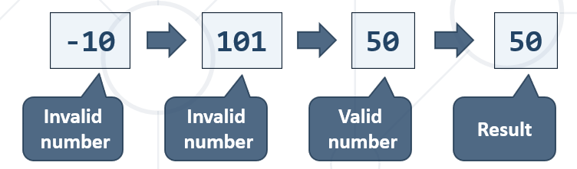

Example
Input | Output |  | Input | Output |  | Input | Output
-10  101  50 | 50 |  | 150  -45  12 | 12 |  | 330  450  89 | 89

Number Processor
Write a program to process a sequence of commands:
  - Read an initial number from the input
  - Read an execute a sequence of the following commands:
    - "Inc" – add 1 to the number (increment)
    - "Dec" – subtract 1 from the number (decrement)
    - "End" – print the number and stop the program

Example
Input | Output |  | Input | Output |  | Input | Output
5  Inc  End | 6 |  | 5  Dec  End | 4 |  | 7  Inc  Inc  Dec  End | 8

